CVEN 4837 - Outdoor Lighting
Reading Summary: Visibility Principles

- Why is the principle of adaptation so important to consider in outdoor lighting applications such as roadway lighting?
Due to the nonuniformity of light present at night on and around roadways, the human eye doesn’t adapt fully to the night, making the need for effective lighting paramount. As mentioned in the reading, headlights of a car driving the opposite direction during the day cause very little pressure for drivers as the road and surrounding luminance is much brighter and the eye is already fully adapted to the large amount of light. At night, the same headlights would render the road difficult to see as their luminance is now much higher in comparison to the road, either overwhelming the eyes (being adjusted to a darker environment) or causing the eyes to adapt to the bright light (causing the road to appear much darker)
- What is contrast sensitivity and why is contrast more important than acuity in outdoor settings?
Contrast sensitivity describes the ability to differentiate between objects and their backgrounds at different levels of luminance, with higher values being found at higher luminance’s. Acuity determines the amount of detail given a set of conditions, however small details are often not useful when driving at night, when the major concerns are staying on the road, avoiding other cars and pedestrians, and avoiding large objects in the road. This translates to more importance being placed on contrast and contrast sensitivity when lighting outdoor areas.
- There are two types of contrast, positive and negative. What are they and is one better for visibility than the other?
Positive and negative contrast determine whether the object has higher or lower luminance than the background. Positive contrast means the object is brighter than the background and negative means the object is darker than the background (silhouetting). I would imagine that positive would be slightly better for visibility, but the main issue for roadway lighting is when the contrast swaps between the two, making the object and background appear very similar in brightness.

- What is threshold contrast and when does it tend to occur? Explain it using this image:
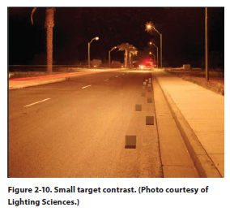
Threshold contrast is the contract level at which an object becomes difficult or impossible to discern from its background due to the lack of contrast between the two. This occurs with the 5th and 6th objects as the light transitions from illumination of the horizontal roadway to the vertical objects.

- What is transient adaptation and what produces it in outdoor settings?
Transient adaptation is the constant adaptation of the eye in changing lighting conditions. In outdoor settings, it can be produced by headlights or other random bits of light that cause glare.

- Visibility at night is affected substantially by the spectral characteristics of a light source. What does that mean for the implementation of IES illuminance standards in outdoor lighting?
Most lights are rated in lumens that have been calculated using the V(λ) curve that only considers photopic vision. Due to the nature of outdoor lighting, most viewing conditions are perceived in the mesopic or scotopic range of vision, meaning the V(λ) curve would appear different due to rods and cones being sensitive to different wavelengths. This means that IES standards that are applied to roadway applications should be analyzed further, as the true appearance of a light may be different when viewed from the scotopic or mesopic range.

- What is the Purkinje shift? Which of these objects, a banana and a plant, will look more vibrant at night?
The Purkinje shift is the shift in sensitivity curve of the human visual system when viewing scenes during photopic and scotopic scenarios. At night, a plant would look more vibrant as scotopic vision is more sensitive to blue-green wavelengths than photopic.

- A high pressure sodium (HPS) as very efficient at generating light as shown in the graph below. Why is it better though to illuminate our streets with white LED light?
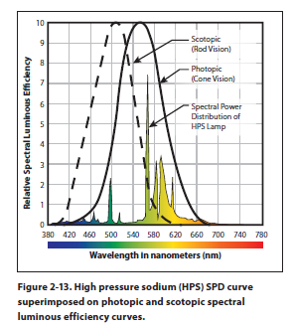
White LEDs often have a large spike in the blue wavelength area, corresponding more closely to the scotopic vision associated with night vision. This means objects under the LED will appear brighter than under a HPS luminaire with the same output.

- Mesopic levels fall between what ranges in cd/m2?
0.001 cd/m^2 and 3.0 cd/m^2

- What is the function of the cones and the rods in mesopic conditions and why are visual responses at night misrepresented with light sources that are calibrated using the photopic luminous efficiency curve?
Cones, concentrated near the center of the eye, account for more photopic vision at the center of focus while the rods, spread around the outside of the eye, are better at peripheral vision in scotopic conditions. Most lights are rated in lumens that have been calculated using the V(λ) curve that only considers photopic vision. Due to the nature of outdoor lighting, most viewing conditions are perceived in the mesopic or scotopic range of vision, meaning the V(λ) curve would appear different due to rods and cones being sensitive to different wavelengths.
- Why is luminance-based design ideal for outdoor applications in particular?
Since luminance is based on the perceived brightness of a surface, designing under luminance conditions will ensure drives can safely operate under night and day conditions since the perceptions of objects light can differ largely under the two scenarios.

